INSTALLATION INSTRUCTIONS
Model # 72592
READ AND SAVE THESE INSTRUCTIONS
WARNING! SHUT POWER OFF AT FUSE OR CIRCUIT BREAKER.

AVERTISSEMENT! COUPER LE COURANT AU NIVEAU DES FUSIBLES OU DU DISJONCTEUR.
Fig. 1
PREPARING FOR INSTALLATION (Fig. 1)
- Shut off the power at the fuse box or circuit breaker box (avertissement! couper le courant au niveau des fusibles ou du disjoncteur) and remove the old fixture, including the mounting hardware.
- Carefully unpack your new fixture and lay out all the parts in a clear area. Take care not to misplace any small parts necessary for installation.
- Remove the pre-punching hole in mounting plate (A). Align mounting plate (A) to the outlet box (C)(not included) and use it as a template to mark the location of the wall anchors (H). Make sure "GND" facing outside. Pre-drill the holes for the wall anchors (H) and insert the anchors into the wall.
- Attach mounting plate (A) using outlet box screws (B) to the outlet box (C) and screws (G) into wall anchors (H), Make sure "GND" facing outside (Fig 1).
CONNECTING THE WIRES (Fig. 2)
- Connect the electrical wires as shown in Fig.2. Make sure that all wire connectors are secured. If your outlet box has a ground wire (green or bare copper), connect the fixture’s ground wire to it. Otherwise, connect the fixture’s ground wire directly to the long strap using the green screw (D) provided.

COMPLETING THE INSTALLATION (Fig. 1)
- Align back plate (F) onto mounting plate (A), and secure with screw (E). (Fig 1)
- To prevent moisture from entering the outlet box (C) and causing a short, use clear silicone sealant to outline the outside of fixture back plate (F) where it meets the wall leaving a space at bottom to allow moisture a means to escape. (Fig.3)
- At this point, install 4*40W/E12/B bulb (no bulb included) in accordance with the fixture specification—DO NOT EXCEED THE MAXIMUM WATTAGE RATING! (NE PAS DEPASSER LA PUISSANCE NOMINALE MAXIMALE!)
Your installation is now complete. Return power to the outlet box and test the fixture.

SET A-021-120270
-Mounting plate
-Ground Screw
-Mounting Screws(2)
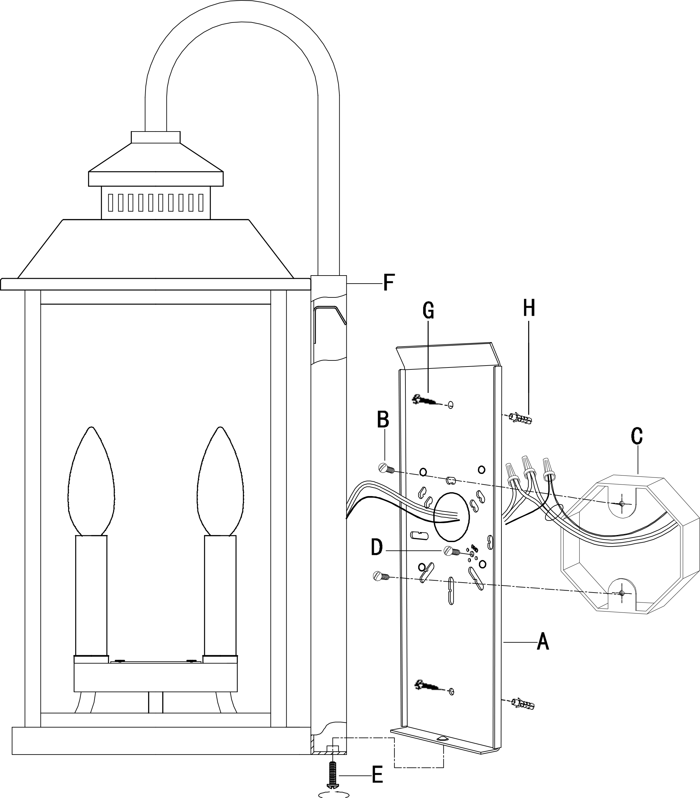

Candle Sleeve # CCV22090P-143
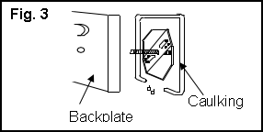

This product is protected by United States Federal and/or State Law, including Patent and/or Copyright laws.
© Minka Lighting Inc.
“CAUTION-RISK OF FIRE CONSULT A QUALIFIED ELECTRICIAN TO ENSURE CORRECT BRANCH CIRCUIT CONDUCTOR”

ATTENTION – RISQUE D’INCENDIE, CONSULTER UN ÉLECTRICIEN QUALIFIÉ POUR VOUS ASSURER QUE LES CONDUCTEURS DE LA DÉRIVATION SONT ADÉQUATS.

